A Data Analysis Report On

**“SHOPNEST STORES SALES”**

As a fulfilment of

CAPSTONE PROJECT

(POWER BI)

Submitted By:

Jagannath Roy

**Submitted to:**

**TEAM SKILLOVILLA**

**ABSTRACT**

**Introduction:**

ShopNest stands as the leading department store in the e-commerce marketplaces in Portugal, serving as

a seamless link connecting small businesses from various regions to online channels. In today's dynamic

business environment, the importance of data analytics cannot be overstated, particularly in enhancing

decision-making and operational efficiency.

**Purpose of the Analysis:**

The purpose of this project is to delve into ShopNest's operations through data analytics, aiming to

uncover insights that drive business growth and optimization. By leveraging the power of data, this

project seeks to provide ShopNest with actionable insights to improve decision-making and operational.

effectiveness.

**Scope of the Analysis:**

This project encompasses a comprehensive range of analyses, including but not limited to top categories

by total price, delayed orders analysis, monthly comparison of delayed and on-time orders, payment

method analysis, product rating analysis, state-wise sales analysis, seasonal sales patterns, and revenue

analysis. Each analysis sheds light on different aspects of ShopNest's operations, contributing to a holistic

understanding of its performance in the e-commerce marketplace.

**Methodology Overview:**

Power BI is utilized as the primary tool for data analysis and visualization in this project. The dataset used

for analysis has been anonymized to ensure confidentiality and privacy. The analytical approach involves a

combination of exploratory data analysis, data visualization techniques, and statistical methods to extract

meaningful insights from the data.

**Expected Outcomes:**

The expected outcome of this project is to provide ShopNest with valuable insights and strategic.

recommendations to optimize its operations, enhance customer experience, and drive business growth.

By harnessing the insights derived from data analytics, ShopNest can make informed decisions that

contribute to its continued success in the e-commerce marketplace.

1. **Question Statement:** Identify the rating distribution in the Shop_Nest dataset, showcasing ratings categorized as Excellent, Very Good, Good, Bad, and Very Bad, along with corresponding orders.

**Visualization:**

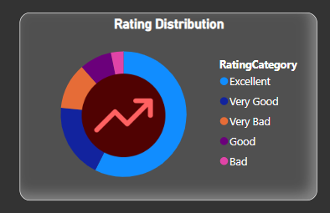

|  |
| --- |
|  |
| **Explanation:** above 50k orders are delivered with the rating of “excellent”  very few orders are delivered with the rating “bad”   1. **Question Statement:** What are the top 10 and bottom 18 most popular product categories in the ShopNest dataset? Please list them based on the number of orders.   **Visualization:**     |  | | --- | |  |  |  |  | | --- | --- | | |  | | --- | |  | |   **Explanation:** here are the top 10 and bottom 18 product categories, here we can see that bed bath table is the top most category and Argo industry is most bottom product. |

1. **Question Statement:** List the total number of active sellers by yearly and monthly

**Visualization:**

|  |
| --- |
|  |
|  |
|  |

**Explanation:** there are more active sellers in 2018 , April and January.

There are less active users in 2016.

**4)Question Statement:** Which payment methods are most commonly used by ShopNest customers.

**Visualization:**

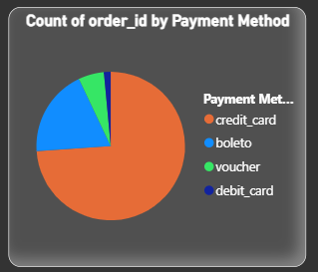

|  |
| --- |
|  |

**Explanation:** 75% customers are using credit cards as the payment methods.

Very less customers are using debit card as the payment methods.

The analysis of payment methods is represented through a pie chart, providing a clear visual breakdown of the most frequently used payment methods by customers.

Key-Insights

• **Most Used Payment Method** – The pie chart helps identify that ‘Credit Card’ payment method are most popular among customers. This can indicate customer preferences and potentially inform strategic decisions around payment options. The payment method that is used most frequently, which might indicate customer trust and satisfaction with that method.

• **Least Used Payment Method** – Debit cards are identified as the least frequently used payment method. This insight can prompt an investigation into why this method is not as popular among customers.

• **Improving Less Used Methods** – Investigate why debit cards are less popular. Potential actions could include improving the user experience, offering incentives, or ensuring better security measures.

**6)Question Statement:** Determine the monthly payments made by customers using credit cards.

**Visualization:**

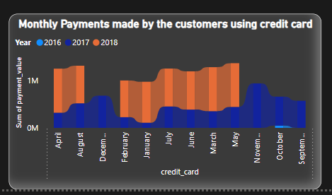

|  |
| --- |
|  |

**Explanation:** In September 2016 payments by credit cards are the lowest.

In April, march, may 2018 payments by credit cards are the highest.

In November 2017 payments made by credit card are also the highest.

**7) Question Statement:** Identify sellers categorized by city, excluding cities starting with the letters S and B.

**Visualization:**

|  |
| --- |
|  |
|  |

**Explanation:** here is the list of all the seller_ids which belongs to seller_cities excluding city starts with B an

**8) Question Statement:** Create a dynamic visual that compares the number of delayed orders to the number of orders received earlier for each month. Utilize the drill through the cross-report feature to provide a detailed analysis of late and on-time deliveries.

**Visualization:**

|  |
| --- |
|  |

|  |
| --- |
|  |

**Explanation:** on-time orders - high in august, low in September.

Delayed orders – high in March, low in September.

**8) Question Statement:** Product category wise profit

Ans: For Argo industries and electro domestics the profit are low.

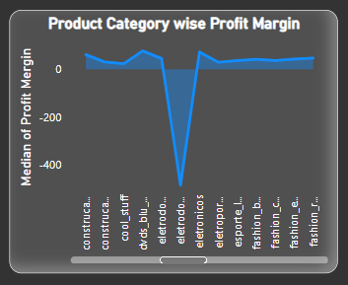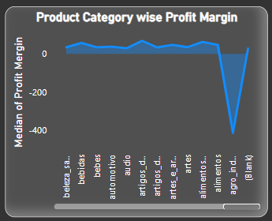

**State-wise Sales Analysis:**

**Insights:**

**1.Revenue Distribution by State:**

States like SP, RJ, and MG appear to contribute significantly to the total revenue, with the highest sums of prices.

**2.Regional Revenue Patterns:**

States in the Southeast region (e.g., SP, RJ, MG) of South America tend to have higher revenue compared to states in other regions.

**3.Customer Concentration:**

Higher revenue states may have larger customer bases or higher average order values, while lower revenue states may have fewer customers or lower purchasing power.

**4.Marketing and Sales Strategies:**

Tailor marketing and sales strategies to target specific regions or customer segments based on revenue patterns. Allocating resources and investments strategically to maximize ROI and capitalize on opportunities for growth helps in maximizing profits.

**5.Customer Satisfaction and Retention:**

Monitoring customer satisfaction and retention rates across different states helps in understanding customers better. Higher revenue states may indicate stronger customer loyalty and satisfaction, while lower revenue states may require additional efforts to enhance customer experiences and loyalty.

**CONCLUSION**

**Fulfilment Efficiency:**

The analysis of delayed orders reveals insights into fulfilment efficiency, highlighting potential challenges in logistics and supply chain management. Addressing systemic issues and streamlining processes can enhance order fulfilment and customer satisfaction.

**Payment Method Preferences:**

Credit card emerges as the dominant payment method, indicating a preference for convenience and flexibility among customers. Offering diverse payment options caters to varying customer preferences and enhances transaction efficiency.

**Product Satisfaction:**

Analysis of product ratings underscores the significance of product quality and customer experience in driving satisfaction and loyalty. Leveraging insights into top-rated products enables businesses to refine offerings and prioritize investments for enhanced customer satisfaction.

**Strategic Implications:**

The insights gathered from these analyses provide valuable guidance for strategic decision-making, resource allocation, and operational enhancements. By leveraging actionable intelligence, organizations can refine processes, optimize sales strategies, and drive sustained business growth and profitability in the competitive e-commerce landscape.

In conclusion, a comprehensive understanding of sales performance, fulfilment efficiency, customer preferences, and revenue trends empowers businesses to make informed decisions and implement targeted strategies for sustained success and competitive advantage in the dynamic e-commerce market

DASHBOARD

